Mujtaba Shahid Faizi

BSCS-5A

#131818

LAB 2 of DIP

**Task 1:**

***Code*:**

**from** PIL **import** Image  
  
im = Image.open(**'JIJIJIJJ.png'**)  
print(im.format, im.size, im.mode)  
im.show()  
f=**'Mujtaba'**  
**outfile = f + ".jpg"**  
**im.save(outfile)**

***Screenshot:***



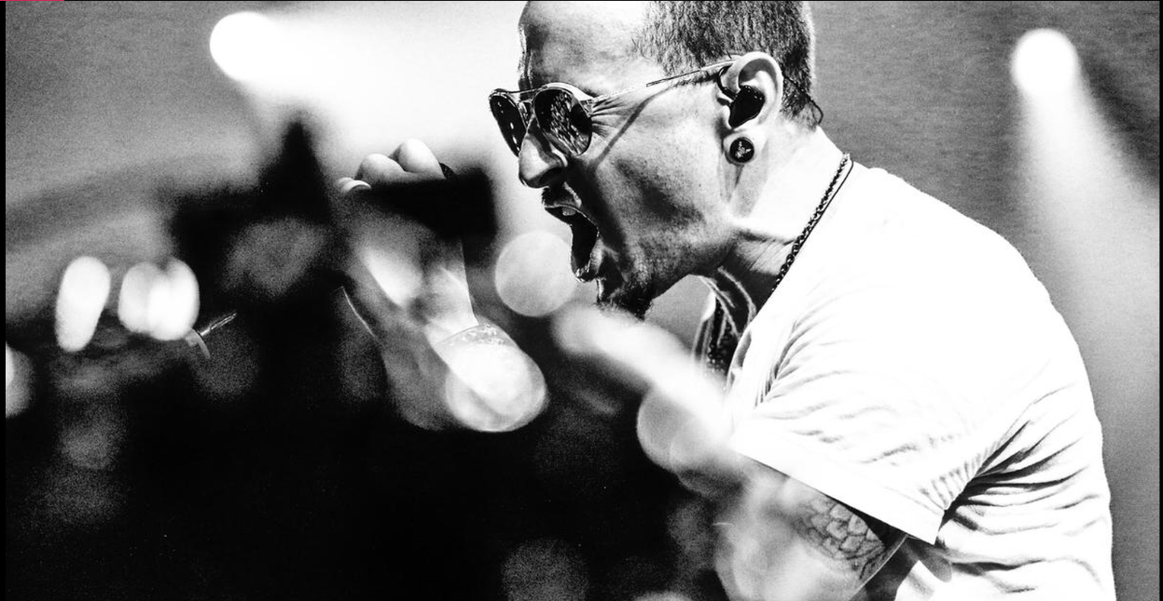

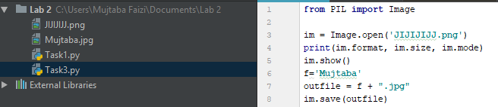

**Task 3 a,b,c:**

***Code:***

**from** PIL **import** Image  
from PIL **import** ImageFilter  
im1 = Image.open(**'F:\Pics & Videos**\NUST Events 2017**\CS-5A\_DSC6837(1).jpg'**).convert(**'LA'**)  
im1.show()  
im = Image.open(**'Mujtaba.jpg'**)  
im2=im.filter(ImageFilter.SMOOTH).show()  
im2=im.filter(ImageFilter.SHARPEN).show()

***Screenshot:***

*Original & greyscale*

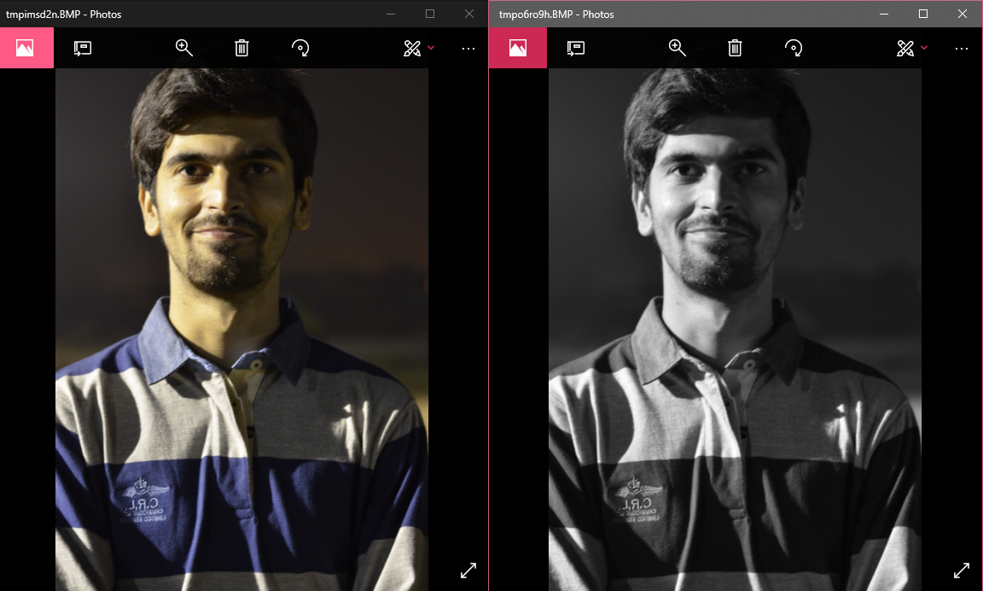

*Smooth & Sharpened*

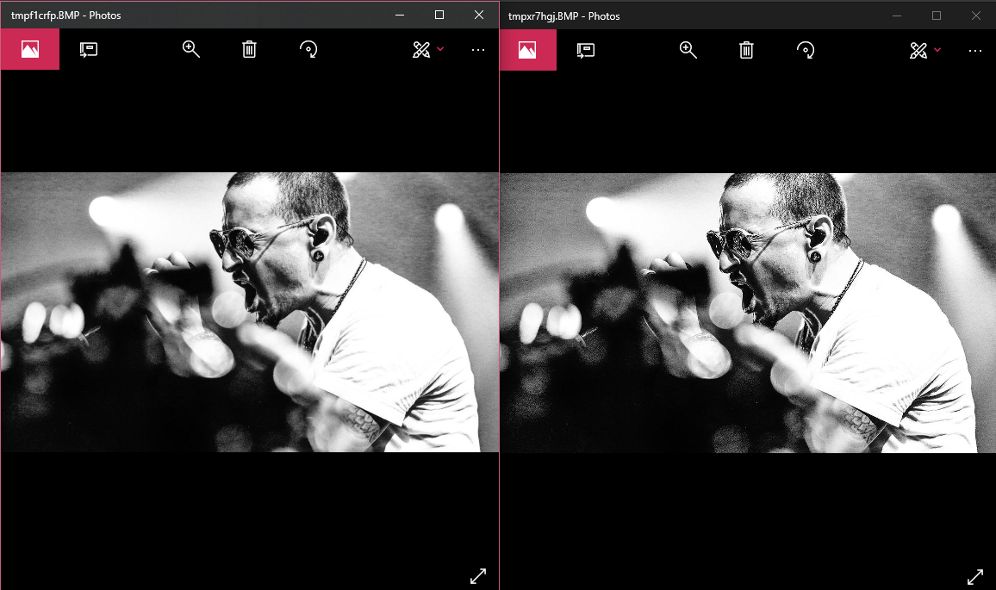

**Task 3 d:**

***Code:***

**from** PIL **import** Image  
import numpy **as** np  
  
def rgb2gray(rgb):  
  
 r, g, b = rgb[:,:,0], rgb[:,:,1], rgb[:,:,2]  
 gray = 0.2989 * r + 0.5870 * g + 0.1140 * b  
 **return** gray  
  
im = Image.open(**'09f9131b9619e7d720a66f9e018b6078.jpg'**)  
array=np.asarray(im)  
b=rgb2gray(array)  
im=Image.fromarray(b)  
im.show()

***Screenshot:***

